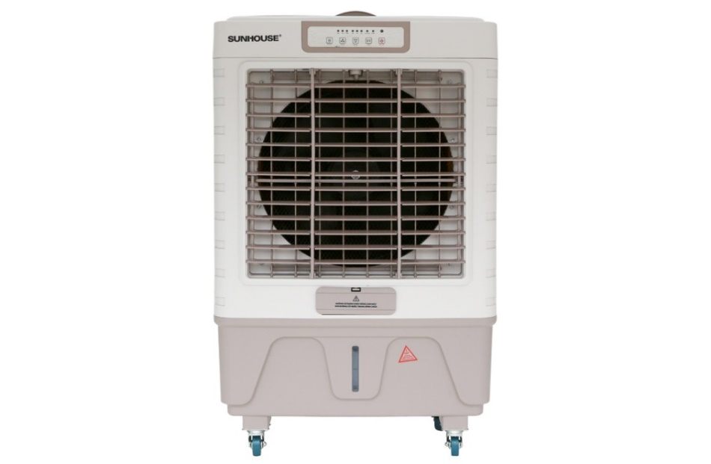

**4.990.000₫**

~~6.850.000₫~~ -27%

**Technical specifications of Sunhouse SHD7746 air conditioning fan**

* Cooling range:

Room < 40m²

* Wattage:

180W

* Wind speed:

3 wind levels

* Control:

There is a remote that comes with a push button

* Highest noise level:

70 dB

* Water bottle:

45 liters

* Utilities:

Has moving wheels Has a cooling dry ice box Has a water level display scale Has a sediment discharge valve for the water tank Has a continuous direct water supply faucet Turn off timer Remote control

* Size, volume:

Width 60.5 cm - Height 98 cm - Depth 41 cm - 14.2 kg

* Brand of:

Vietnam

* Made in:

China

* The firm

Introducing the company 

- Vietnamese brand, with Korean joint venture capital in 2010.  
- Established in 2000.  
- Known to the majority of users with more than 450 product groups of household electrical appliances and household appliances such as gas stoves , electric stoves, pots, pans, rice cookers, electric kettles...

- Sunhouse's products win the hearts of Vietnamese people with affordable prices, guaranteed quality, diverse designs and models to meet the needs of customers. all users.

[**Sunhouse SHD7746 air conditioning fan**](https://www.dienmayxanh.com/quat-dieu-hoa/sunhouse-shd7746)**with 2 pieces of dry ice quickly reduces heat, increasing cooling ability**

When using, fill the ice bottle with water and put it in the freezer compartment, then take it out and put it in the dry ice compartment in the fan and use it like regular dry ice.

[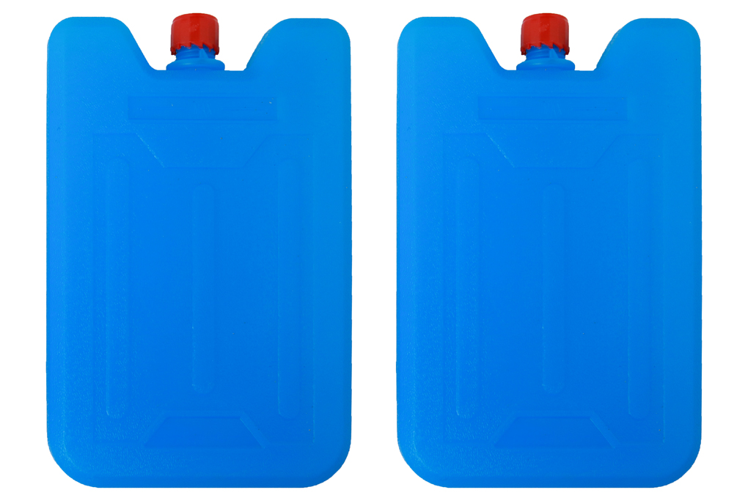](https://cdn.tgdd.vn/Products/Images/1992/114839/sunhouse-shd7746-12.jpg)

**Powerful 180W capacity, suitable for cooling areas under 40m2**

The main motor is wound with copper wire, the water pump motor is wound with aluminum wire, operating smoothly and durable.

The fan has 4 wheels, 2 of which have locks to help fix the fan's position.[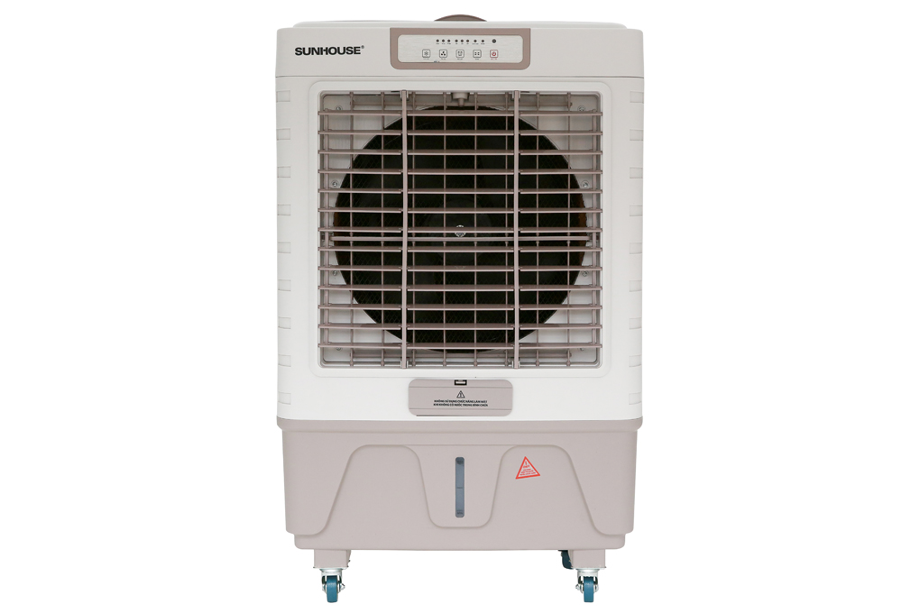](https://cdn.tgdd.vn/Products/Images/1992/114839/sunhouse-shd7746-1.jpg)

Noise level from 60 - 70 dB suitable for restaurants, cafes,...

[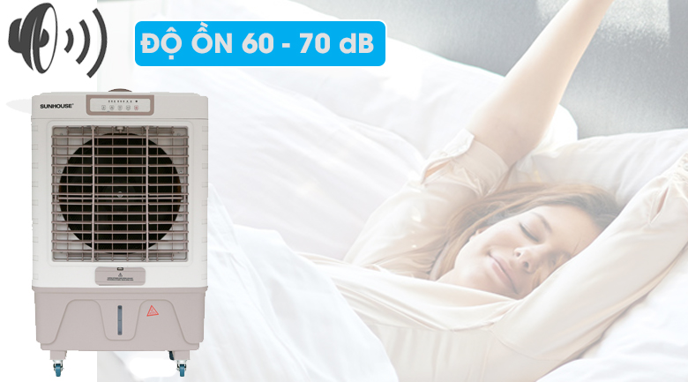](https://cdn.tgdd.vn/Products/Images/7498/114839/sunhouse-shd7746-16.jpg)

**There are 3 cooling panels located on the sides and back to help increase cooling capacity**

[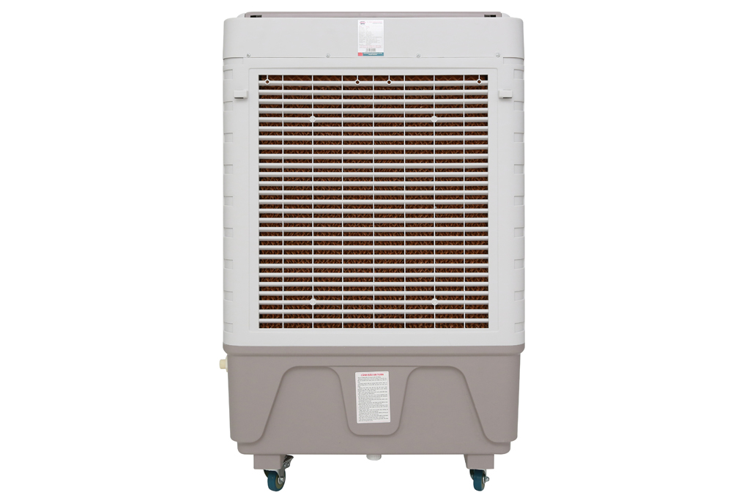](https://cdn.tgdd.vn/Products/Images/1992/114839/sunhouse-shd7746-4.jpg)

[**Air conditioning fan**](https://www.dienmayxanh.com/quat-dieu-hoa)**with 45 liter water tank capacity, meets the need for continuous cooling for many hours, has a wide water filling door, easy to refill**

[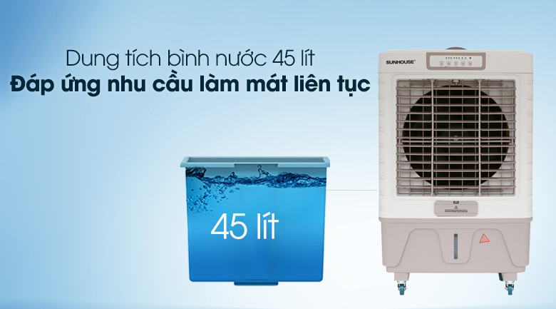](https://cdn.tgdd.vn/Products/Images/7498/114839/sunhouse-shd7746-17.jpg)

When the water tank is empty, if the user selects cooling mode, the fan still operates normally, with no warning light. When you want to clean the tank, drain the water using the drain valve at the bottom of the tank located between the two rear wheels.

The fan has an additional water line to the automatic tank, making refilling the fan more convenient.

[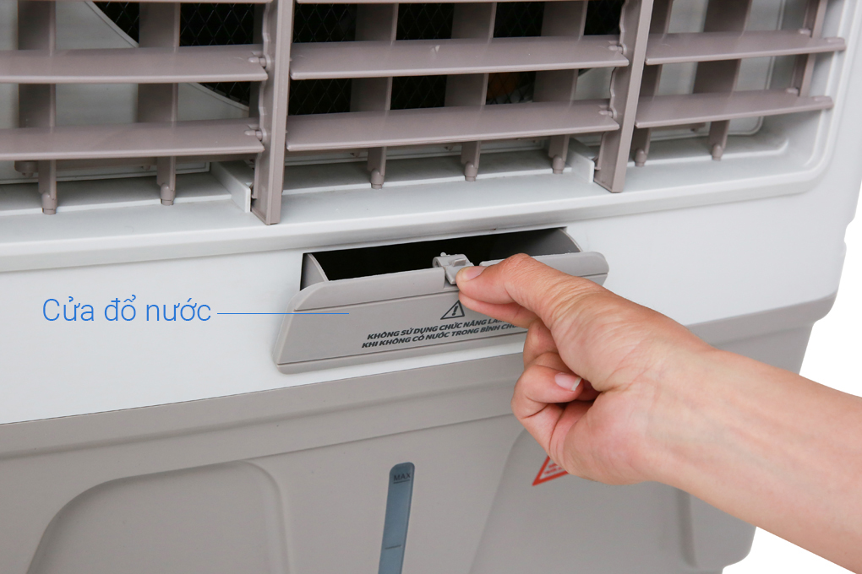](https://cdn.tgdd.vn/Products/Images/1992/114839/sunhouse-shd7746-10.jpg)

**The scale displays the water level clearly, making it easy to monitor and fill water**

[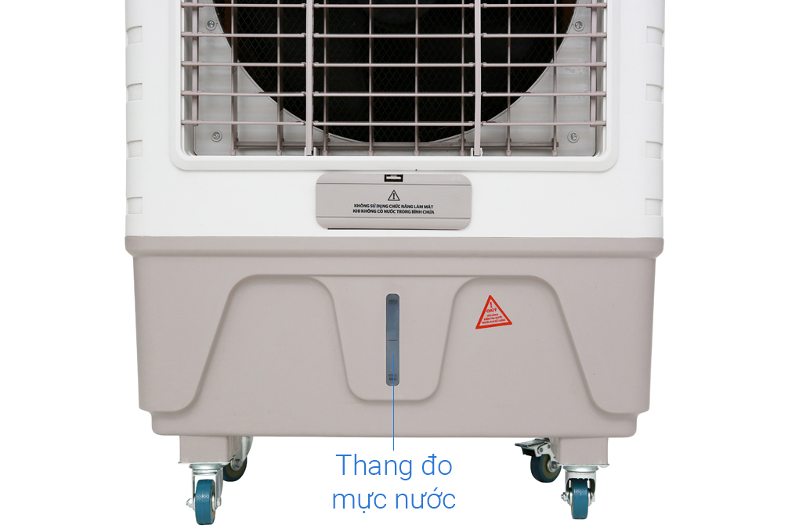](https://cdn.tgdd.vn/Products/Images/1992/114839/sunhouse-shd7746-7.jpg)

**Easy to use with push button control panel with Vietnamese instructions, maximum off timer up to 7 hours**

[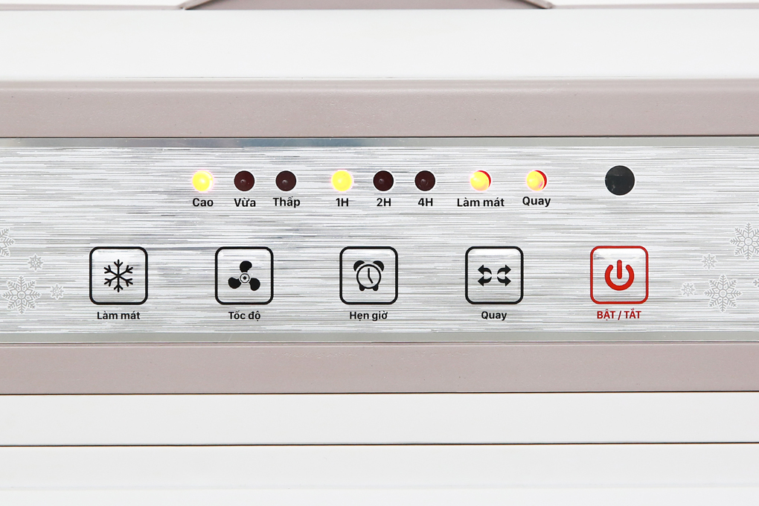](https://cdn.tgdd.vn/Products/Images/1992/114839/sunhouse-shd7746-5.jpg)

**Compact remote control with function keys with easy-to-understand Vietnamese instructions, simple operation**

[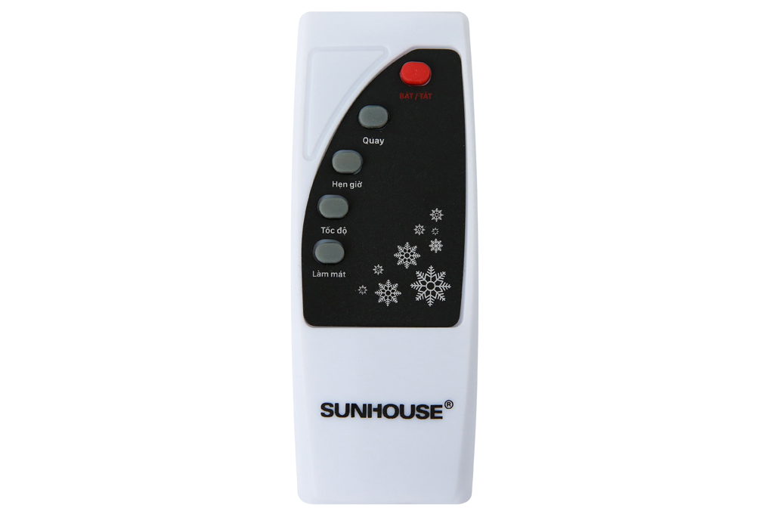](https://cdn.tgdd.vn/Products/Images/1992/114839/sunhouse-shd7746-11.jpg)

[**Sunhouse SHD7746 air conditioning fan**](https://www.dienmayxanh.com/quat-dieu-hoa/sunhouse-shd7746)**launched in 2018, reputable Vietnamese brand - Sunhouse, made in China**

Notes to  [use air conditioning fans effectively](https://www.dienmayxanh.com/kinh-nghiem-hay/cach-su-dung-quat-dieu-hoa-831809) :

- Air conditioner fans only have the ability to cool the air, not the cooling ability like an air conditioner.

- Placing a fan in the corner of the room will help the wind spread throughout the room, providing a natural wind flow that is good for your health.

- Place the fan at least 20 cm away from the wall so that the fan has space to get air.

- Clean the fan regularly and the water in the tank is clean to avoid bacteria from growing, causing odors and affecting health.

- Comes with 2 boxes of dry ice, so for the most effective cooling, use with the included box of dry ice.

- You should add water before plugging the power cord into the power source. If you are using a fan, turn it off and unplug the power cord before filling it with water, then start it up and use it again.

- Unplug the power cord when not using the fan to save more electricity.

[Sunhouse SHD7746 air conditioning fan](https://www.dienmayxanh.com/quat-dieu-hoa/sunhouse-shd7746) is a good product used for large spaces and public areas, operating stably and conveniently.